# 9 Communication in the Digital Age,

How Can I Become a More Effective Communicator?

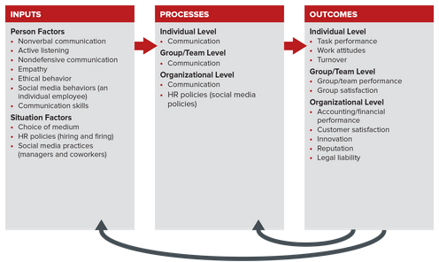

## 9.1 BASIC DIMENSIONS OF THE COMMUNICATION PROCESS,

Defining Communication

Communication is “the exchange of information between a sender and a receiver, and the inference (perception) of meaning between the individuals involved.” It is a circular and dynamic process in which people interpret and make sense of the information they exchange. And it’s a very important activity in both our personal and professional lives.

How the Communication Process Works,

We all know communicating is neither simple nor clear-cut. Researchers have begun to examine it as a form of social information processing in which receivers interpret messages by cognitively processing information. This work has led to development of a perceptual model of communication that depicts it as a process in which receivers create meaning in their own minds. Let us consider the parts of this process and illustrate them with an example (see Figure 9.2).

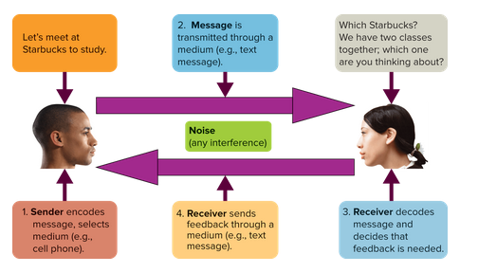

Sender, Message, and Receiver

The sender is the person or group wanting to communicate information—the message. The receiver is the person, group, or organization for whom the message is intended.

Page 339

Encoding

Communication begins when a sender encodes an idea or thought. Encoding means translating thoughts into a form or language that can be understood by others. This language becomes the foundation of the message. For example, if a professor wants to communicate with you about an assignment, he or she must first think about what information to communicate. Once the professor has resolved this issue in his or her mind (encoding), the next step is to select a medium in which to communicate.

Selecting a Medium

Managers can communicate through a variety of media. These include face-to-face conversations and meetings, telephone calls, charts and graphs, and the many digital messaging forms—e-mail, texting, voice mail, videoconferencing, Twitter, Facebook, Blackboard, and others. We discuss the best way to select a medium in the next section.

Decoding and Creating Meaning

Decoding, the process of interpreting or making sense of a message, occurs when receivers receive a message. When a professor communicates with you about an assignment, for example, you decode the message when you receive it.

The perceptual model of communication assumes the receiver creates the meaning of a message in his or her mind. This means different people can interpret the same message differently.

Feedback,

The first round of feedback occurs when the original receiver expresses a reaction to the sender’s message. Once the initial sender has obtained this feedback, he or she is likely to decode it and send corresponding feedback. This process continues until sender and receiver believe they have effectively communicated.

Noise,

Noise is anything that interferes with the transmission and understanding of a message. There are many other sources of noise: language differences, speech impairment, illegible handwriting, inaccurate statistics, poor hearing and eyesight, environmental noises, other people talking, faulty equipment, and physical distance between sender and receiver. Noise affects all the links in the communication process. Nonverbal communication, discussed later in this chapter, also is a source of noise, as are cross-cultural differences between senders and receivers, and the physical work environment.

Selecting the Right Medium,

Media Richness

Media richness measures the capacity of a given communication medium to convey information and promote understanding. Media vary from rich to lean. The richer a medium, the better it is at conveying information. Four factors affect richness:

Speed of feedback. Faster feedback offers more richness.

Channel. The visual and audio characteristics of a videoconference are richer than the limited visual aspects of a written report.

Type. Personal media such as phone calls and interpersonal speech are richer than impersonal media such as memos and group emails.

Language source. The natural body language and speech in a face-to-face conversation provide a richer medium than the numbers in a financial statement.

Complexity of the Situation

Situations can range from low to high in complexity. Low-complexity situations are routine and predictable, such as a manager updating employees on last month’s sales or calculating someone’s paycheck. Highly complex situations, such as a corporate reorganization or merger, are ambiguous, hard to analyze, and often emotionally charged.

Picking the Right Medium,

A two-way face-to-face conversation is the richest form of communication. It provides immediate feedback and allows participants to observe multiple cues such as body language and tone of voice. Use face-to-face in situations that are complex or that are highly important to receivers. In contrast, telephone conversations and videoconferencing are not as informative as face-to-face exchanges even though they are relatively high in richness. For example, webinars and WebEx presentations are well suited for disseminating information, but we can say from experience that they are not as good for ensuring the messaging has been understood. At the other end of the complexity scale, newsletters, computer reports, and general e-mail blasts are lean media and best for less complex situations. E-mail and social media messages vary in media richness: leaner if they impersonally blanket a large audience, and richer if they mix personal textual and video information that prompts quick conversational feedback.

## 9.2 Communication Competence,

Sources of Nonverbal Communication

Nonverbal communication is communication without words. According to communication experts “it includes observable behaviors such as facial expressions, eyes, touching, and tone of voice, as well as less obvious messages such as dress, posture, and spatial distance between two or more people.”

Nonverbal communication adds flavor to oral communication. That is, it helps you understand the attitudes and emotions of those with whom you are speaking, which in turn helps you more accurately interpret their message.

Let’s consider four key sources of nonverbal messages:

1. Body movements and gestures.
2. Touch.
3. Facial expressions.
4. Eye contact.

Eye Contact,

Eye contact is a strong nonverbal cue that varies across cultures. Westerners are taught at an early age to look at their parents when spoken to. In contrast, Asians are taught to avoid eye contact with a parent or superior in order to show obedience and subservience. Once again, you need to be sensitive to different orientations toward maintaining eye contact with diverse employees.

Listening,

Listening is the process of actively decoding and interpreting verbal messages. It requires cognitive attention and information processing; simply hearing does not. There is general consensus that listening is a cornerstone skill of communication competence.

Unfortunately, many of us think we are good listeners when evidence suggests just the opposite. For example, researchers estimate that typical listeners retain only 20 to 50 percent of what they hear.

Why do you think we miss or lose so much of what we hear? One reason is that we have the cognitive capacity to process words at a much higher rate than people speak. This means our cognitive processes are being underutilized, leading to daydreaming and distractions. Noise is another reason. A third reason, and one you can control, is your motivation to listen and your listening style. It takes effort to actively listen. You won’t be a better listener unless you are motivated to become one.

What’s Your Listening Style—or Styles?

You can improve your communication competence by understanding your typical listening style. There are four styles:28

Active—I’m fully invested. Active listeners are “all in.” That is, they are motivated to listen and give full attention when others are talking. They focus on what is being communicated and expend energy by participating in the discussion. They also use positive body language, such as leaning in or making direct eye contact, to convey interest.

Involved—I’m partially invested. Involved listeners devote some, but not all, of their attention and energy to listening. They reflect on what is being said and halfheartedly participate in the discussion. Their use of nonverbal cues tends to be inconsistent or intermittent, and they can show nonverbal signs of interest and noninterest in the same conversation.

Passive—It’s not my responsibility to listen. Passive listeners are not equal partners in a speaking–listening exchange. They assume the speaker is responsible for the quality of the interaction and believe their role is to passively take in information. Passive listeners will display attentiveness, but they can fake it at times. Overall, they don’t expend much motivation or energy in receiving and decoding messages.

Detached—I’m uninterested. Detached listeners tend to withdraw from the interaction. They appear inattentive, bored, distracted, and uninterested. They may start using mobile devices during the speaking–listening exchange. Their body language will reflect lack of interest, such as slumping and avoiding direct eye contact.

Becoming a More Effective Listener,

Effective listening is a learned skill that requires effort and motivation. It comes down to paying attention to the content of the message. The suggestions in Table 9.1 can increase your listening skills at school, home, and work.

Nondefensive Communication

Defensiveness occurs when people perceive they are being attacked or threatened. Our “first responder” to defensiveness is the brain’s amygdala. A neuroscience expert Page 346noted the amygdala “accesses emotional memories that identify a given stimulus as potentially threatening and triggers the emotional fear response that sets the fight-or-flight biobehavioral response in motion.” This reaction leads to defensive listening and destructive behaviors such as shutting down or being passive-aggressive, standing behind rules or policies, creating a diversion, or counterattacking.

You may be surprised to learn that defensiveness is often triggered by nothing more than a poor choice of words or nonverbal posture during interactions. In the language of behavior modification, these triggers are antecedents of defensiveness. For example, using absolutes like “always” or “never” is very likely to create a defensive response. Try to avoid using absolutes because they are rarely true. Instead, you can increase your communication competence by avoiding the defensive antecedents and employing the positive antecedents of nondefensive communication shown in Table 9.2

Connecting with Others via Empathy

We first mentioned empathy in Chapter 3 when discussing the components of emotional intelligence. Although researchers propose multiple types of empathy, the general consensus is that empathy represents the ability to recognize and understand another person’s feelings and thoughts. It is a reflective technique that fosters open communication.

## 9.3 Gender, Generations, and Communication,

Linguistic style refers to a person’s characteristic speaking pattern. It includes such features as directness or indirectness, pacing and pausing, word choice, and the use of such elements as jokes, figures of speech, stories, questions, and apologies. In other words, linguistic style is a set of culturally learned signals by which we not only communicate what we mean but also interpret others’ meaning and evaluate one another as people.

Communication Patterns between Women and Men

There are two competing explanations about the origin of linguistic styles between men and women. Some researchers believe interpersonal differences between women and men are due to inherited biological differences between the sexes. This perspective, also called the evolutionary psychology or Darwinian perspective, attributes gender differences in communication to drives, needs, and conflicts associated with reproductive strategies used by women and men. The second perspective, social role theory, suggests that girls and boys are taught to communicate differently. Here is what these explanations suggest about male and female communication patterns.

Page 349

The Male Perspective

Males are expected to communicate more aggressively, interrupt others more than women, and hide their emotions because they have an inherent desire to possess features attractive to females. Men also see conversations as negotiations in which people try to achieve and maintain the upper hand. Thus they feel it is important to protect themselves from others’ attempts to put them down or push them around. This perspective increases a male’s need to maintain independence and avoid failure. Although males are certainly not competing for mate selection during a business meeting, evolutionary psychologists propose that men cannot turn off the biologically based determinants of their behavior.

Generational Differences in Communication

As discussed in Chapter 4, today’s workplace often includes people from four different generations—traditionalists, baby boomers, Gen Xers, and Millennials (Gen Ys). (Refer to Table 4.3 for additional details and characteristics.) Among the challenges in this scenario is the fact that different generations prefer different media, as discussed above, and they have different expectations and norms about communication.

Improving Communications between the Sexes and Generations

It’s unwise to generalize any trends, preferences, or perceptions to all men, all women, or all members of a particular generation. Some men, for instance, are less likely to boast about their achievements, while some women are less likely to share the credit. Some traditionalists embrace technology and new communication practices, while not all members of Gen Y are technological whizzes. There are always exceptions to the rule. In recognition of that fact, here are some suggestions that can enhance your communication competence:

Clarify communication expectations and norms. If your manager fails to discuss these, bring the topic up. It’s better to understand expectations than to guess wrong. After all, you are the one who will lose if people form negative perceptions about your communication skills and patterns.

Use a variety of communication tools. Regardless of your preferred mode of communication (such as face-to-face or texting), employees from all generations should use a variety of media according to the circumstances. This avoids alienating any particular generation.

Be aware of implicit cognition. Don’t assume, based on somebody’s gender or age, that he or she only likes one mode of communication. If you find males interrupting, gently call them out. If someone is quiet in a meeting, ask for his or her opinion.

Make sure people get credit for their ideas and not their gender. Sometimes a woman “will say something, and it’s not acknowledged until a guy says it later,” Paul Gotti, Cardinal Health’s vice president of nuclear pharmacy services, says. He makes sure to credit the woman and ask her to elaborate.

## 9.4 Social Media and Ob,

Social media use web-based and mobile technologies to generate interactive dialogue with members of a network. Social media are now woven throughout the fabric of our lives. Their use affects many subjects covered in this book, highlighting the importance of communication as an OB topic. Social media are now used by a significant proportion of people across all age groups (see Figure 9.3 for utilization rates by age).

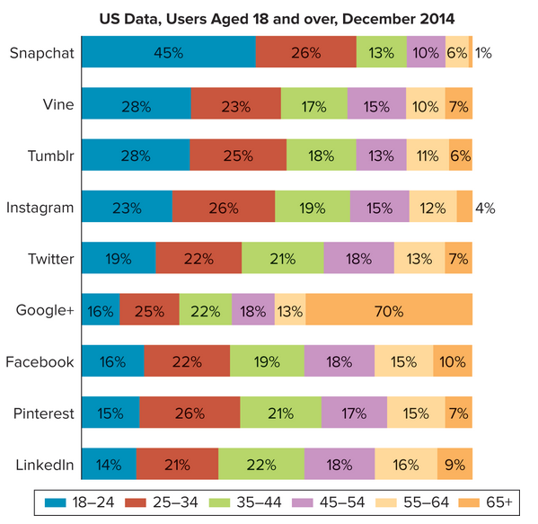

Employee Productivity

Evidence is mounting that social media confers a host of benefits for employees, such as

Increased job satisfaction and better work–life balance.

Performance and retention.

More creativity and collaboration.

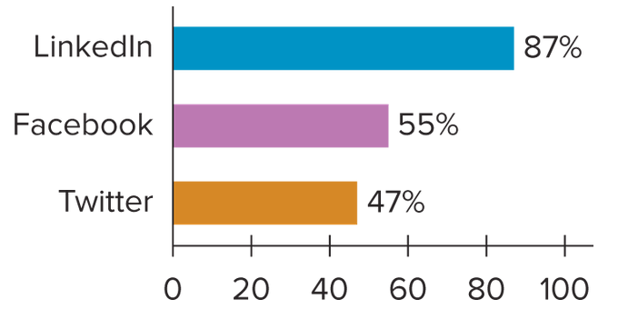

Employer Productivity

Companies of all sizes and industries believe in the benefits of social media. Procter & Gamble (P&G), for instance, spends more than any other company on advertising, and it now devotes more than a third of its US marketing budget to digital media. Marc Pritchard, global brand officer, says, “Digital technology … is enabling P&G to expand creativity with an unprecedented delivery machine that is constantly evolving.… This is why P&G is quickly shifting to a digital-first approach to building brands.” If deployed effectively, social media enable businesses to realize the many benefits outlined in Table 9.3.

Table 9.3 Social media benefits for employers

benefit: Connect in real time over distance,

Description: Employees, customers, communities, suppliers, prospective talent, and many others can communicate as needed and while work is being completed.

benefit: Collaborate within and outside the organization,

Description: Linking sources of knowledge is a means for realizing the potential of employee diversity and enhancing productivity. Social media is by definition a way of connecting people virtually, so its effective implementation benefits virtual teamwork.

benefit: Expand boundaries,

Description: Social networks can become critical means for organizational innovation and effectiveness, allowing them to utilize knowledge, skills, and experience of people outside (not employed by) the organization.

Costs of Social Media, Perhaps the biggest problem with such productivity losses is that employees rarely think about them. Have you ever thought you were cheating your employer by checking Facebook, sending a tweet, or booking a trip during work hours? Did you ever think the message you sent a friend about work might be shared and give a competitor an advantage?

Make E-mail Your Friend, Not Your Foe

E-mail is not only one of the most useful communication tools but also one of biggest drains on your productivity. Recent estimates suggest that 40 percent of white-collar workers spend at least three hours each weekday checking work e-mail.68 If we add in some amount of non-work e-mail, the time it consumes is truly immense! Most people acknowledge that e-mail is essential, but handling it effectively can make it your friend instead of your foe. See Table 9.4 for the benefits and drawbacks, and Table 9.5 for tips on managing e-mail.

TABLE 9.5 E-Mail: Tips for Managing.

Do not assume e-mail is confidential.

Employers are increasingly monitoring employees’ e-mail. Assume all your messages can be read by anyone.

Be professional and courteous.

Delete long message streams, don’t send chain letters and jokes, don’t type in all caps (it’s equivalent to shouting), wait and consider before responding to a nasty e-mail, refrain from using colored text and background, don’t expose your contact list to strangers, and be patient if you must wait to receive a reply.

Avoid sloppiness.

Use a spell checker or reread and edit your messages before sending.

Don’t use e-mail for volatile, complex, or highly personal issues. Use a medium that is appropriate for the situation at hand.

Keep messages brief and clear. Use accurate subject headings and let the reader know what you want up front.

Save readers time. Type “no reply necessary” in the subject line or at the top of your message if appropriate.

Be careful with attachments. Large attachments can crash someone’s system and use up valuable time downloading. Send only what is necessary, and get receivers’ permission to send multiple attachments.

Social Media Concerns and Remedies—What Companies and You Can Do.

Be Careful about Blocking Access

Banning access can damage employee morale and loyalty—potentially leading to even greater losses in productivity. Some experts argue, and most employees would agree, that small breaks during the workday help boost productivity. Such breaks can take the form of going outside to get a breath of fresh air, talking with a colleague over a cup of coffee, checking personal e-mail or Facebook, or checking and sending tweets.

Adopt a Social Media Policy

Despite the pervasive use of social media, fewer than 50 percent of companies have an actual social media policy. If the costs and concerns noted above aren’t enough to motivate your employer to create a social media policy that describes the who, how, when, and for what purposes of social media use, and the consequences for noncompliance, consider what can happen without such a policy. Do you recall the photos and videos of Taco Bell and Domino’s Pizza employees in disgusting acts with food? “These viral moments do more than turn stomachs,” writes business commentator Anthonia Akitunde. “[T]hey point to a troubling trend: employees abusing social media on the job to the detriment of the brand.”

One way to help prevent such nightmares is to create, communicate, and enforce effective social media policies. The elements of an effective social media policy are outlined in Table 9.6.

Privacy,

Any discussion of the effective use of social media by employees or their employers must include privacy issues. People and companies have reputations, which are built over time and can be extremely consequential professionally. They can also be damaged in a variety of ways, with serious consequences including loss of employment or business, social stigma, embarrassment and stress, lost opportunities, and, of course, legal action. Many lawsuits now routinely include the content of online profiles, e-mail, instant messaging, videos, photos, and other information retrieved from social media to make the cases for and against individuals and organizations.

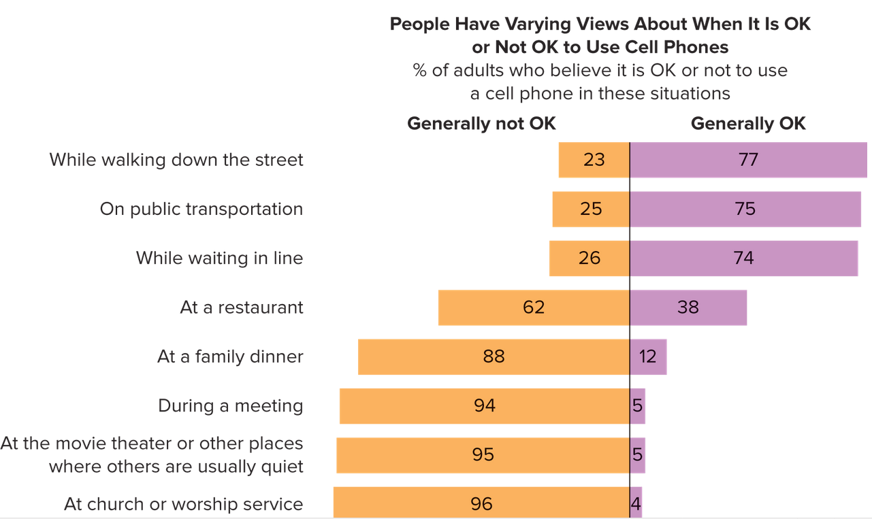

## 9.5 Communication Skills to Boost Your Effectiveness,

Presenting—Do You Give Reports or Do You Tell Stories?

As you learned earlier, different communication media are better than others for any given message. The challenge for you is to know what your audience wants and needs, and then to construct and deliver your presentation accordingly. It generally is more effective if you present your message more as a colorful story with emotion than as a detail-laden report. The people who organize the TED (Technology, Education, Design) talks have a five-step protocol they use to guide their presenters to deliver with impact.

Step 1. Frame your story.

Step 2. Plan your delivery.

Step 3. Develop your stage presence.

Step 4. Plan your multimedia.

Step 5. Put it together.

Crucial Conversations,

“Crucial conversations are discussions between two or more people where (1) the stakes are high, (2) opinions vary, and (3) emotions run strong.” Such conversations Page 367can and do occur in all arenas of your life—school, work, and socially. Examples of relevant occasions include:

STATE: How to Be Effective When It’s Crucial

The acronym STATE will help you address even the most difficult conversations with a plan or path to follow.

1. Share your facts. Start with the least controversial, most persuasive elements that support what you want for yourself and for the relationship.
2. Tell your story. Enhance what you want by describing what has happened, how you’ve arrived where you are, how you’d like to see it change, and why. It may help to add what you don’t want personally or for the relationship.
3. Ask for others’ facts and stories. This is key to creating dialogue, which is essential if you’re to have a productive crucial conversation. Don’t talk at but instead talk with others. Approach all crucial conversations as two-way exchanges. Don’t be accusatory, but instead simply describe the situation, the way you feel, and what you would like to see happen. Use “I” instead of “you.”
4. Talk tentatively. Keep in mind that you’re telling a story, not stating facts. The facts come first, then you can add “color” or describe the impact on you via your story. In other words, don’t pound the podium and talk like you’re “preaching” facts.
5. Encourage testing. Make it safe for others to share their (opposing) views. Allow them to share or test their ideas, thoughts, and feelings. Don’t interrupt, steamroll, or intimidate. It is critical to maintain mutual respect during crucial conversations. One way to do this is to explain and focus on mutual purpose—what you both stand to gain. Be sure the other person respects you in order to avoid defensiveness (recall what you learned earlier in this chapter) and conflict. If it’s appropriate, apologize to get back on track.

Managing Up,

Gauge Receptiveness to Coaching,

Many organizations now claim they believe in the merits of employee involvement and feedback, even upward feedback. Note that translating these values into action requires skill. The place to begin is by assessing your manager’s receptiveness. Regardless of your organization’s policy or comments from senior leadership, if your manager is not receptive, you’re wise to put your efforts elsewhere. You can’t coach a boss who doesn’t want to be coached. To gauge receptiveness, you can: